**Use Case Descriptions and Diagrams for RapidReach (UC01-UC07)**

UC01 - Look up Item Availability

| ***Use Case Name*** | Look up Item Availability (UC01) |
| --- | --- |
| ***Goal*** | Allow customer or store associate to check availability of a specific item in inventory. |
| ***Actors*** | * Primary: Customer, Warehouse Staff, Customer Service Representative, Delivery Driver |
| ***Stakeholders*** | * Customer – Ensures they can find and purchase the desired item. * Warehouse Staff – Confirms inventory levels and restocks as required. * Customer Service Team – Assists customers by providing real-time availability updates and handling inquiries. * Delivery Driver – Checks stock levels before fulfilling or picking up items for delivery. |
| ***Pre-Conditions*** | * The inventory system must be updated with real-time stock information. * The system must be accessible from the customer portal, internal tools for customer service, warehouse staff, and driver dispatch systems. |
| ***Post-Conditions*** | * System displays the item's availability status (in stock, low stock, out of stock). * Warehouse staff and delivery drivers receive updates regarding stock levels for order fulfillment. * Customer service team can provide accurate responses based on real-time inventory data. |
| ***Triggers*** | A customer, warehouse staff, customer service representative, or delivery driver initiates a request to check the availability of an item. |
| ***Main Success Scenario*** | 1. The actor (customer, warehouse staff, customer service rep, or delivery driver) logs into the system or accesses via appropriate interface. 2. System prompts the user to enter the item name or SKU. 3. System retrieves real-time inventory data. 4. System displays the item’s availability, location (if applicable), and stock count. 5. If item is available, system provides the user with the option to add the item to their cart, proceed with an order, or reserve the item for pickup. 6. If item is unavailable, system provides alternative product recommendations or allows user to request restock on item. |
| ***Alternative Paths*** | (3) Item not found: System suggests similar items or prompts re-entry of the item info.  (4) System error: System displays an error message and prompts user to try again.  (5) Low stock: System allows the user to request a restock or send a notification to the user when item is back in stock. |

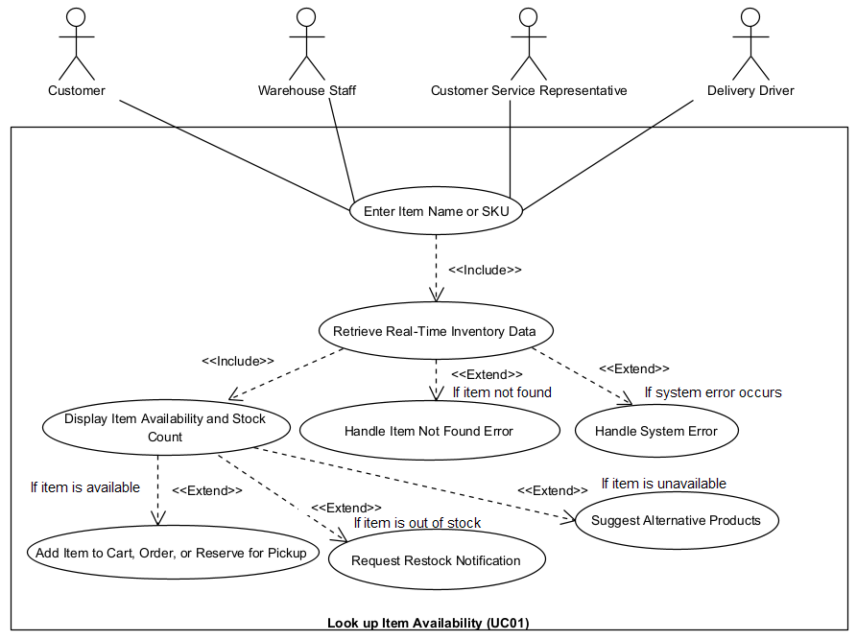

UC02 - Produce Report

| ***Use Case Name*** | Produce Report (UC02) |
| --- | --- |
| ***Goal*** | Generate a customer summary report at the end of the month for marketing purposes. |
| ***Actors*** | * Primary: Marketing Team (Receives and reviews report) |
| ***Stakeholders*** | * Marketing Team - Uses customer reports for analysis and strategic planning |
| ***Pre-Conditions*** | * Customer data must be stored in the system. * The reporting system must be scheduled to run at the end of the month. |
| ***Post-Conditions*** | * The customer summary report is available to the Marketing Team. |
| ***Triggers*** | End of the month, triggering the system to generate the report. |
| ***Main Success Scenario*** | 1. The system detects the end-of-month event. 2. The system compiles customer data and generates the summary report. 3. The system stores the report in the designated repository. 4. The system notifies the Marketing Team that the report is available. 5. The Marketing Team accesses the report for review. |
| ***Alternative Paths*** | (2) Data is inconsistent: The system flags errors and sends an alert for manual review.  (3) Report generation failed: System retries, if failed again then notify an administrator. |

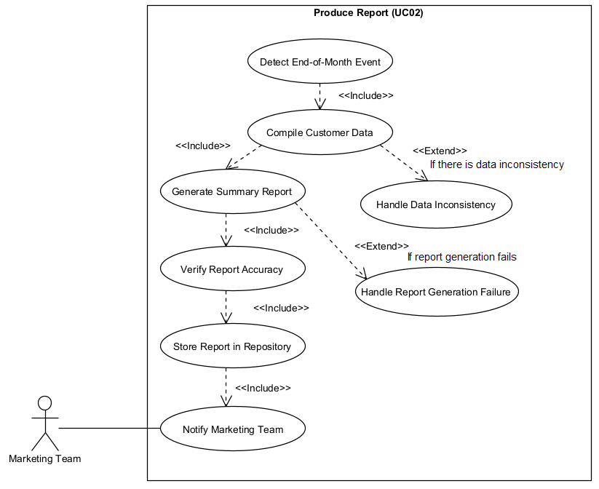

UC03 - Place Order

| ***Use Case Name*** | Place Order (UC03) |
| --- | --- |
| ***Goal*** | Enable customers to place orders online for available items and process them efficiently. |
| ***Actors*** | * Primary: Customer * Supporting: Warehouse Staff, Customer Service Representative, Delivery System |
| ***Stakeholders*** | * Customer – Ensures a seamless shopping experience by allowing them to place and confirm orders. * Warehouse Staff – Receives order details to prepare for dispatch. * Customer Service Representative – Assists customers with order inquiries and modifications. * Delivery System – Manages driver assignment and tracking for order fulfillment. |
| ***Pre-Conditions*** | * The customer must be logged into the system. * Items must be in stock for successful order placement. * Payment and delivery options must be configured.. |
| ***Post-Conditions*** | * SysteThe order is recorded in the system. * Warehouse staff is notified for fulfillment. * The delivery system is updated for driver assignment and tracking. * Customers receive order confirmation and tracking details. |
| ***Triggers*** | A customer initiates an order by adding items to the cart and proceeding to checkout. |
| ***Main Success Scenario*** | 1. The customer selects items and adds them to the cart. 2. The system verifies stock availability. 3. The customer proceeds to checkout and enters shipping details. 4. The system calculates total cost and applies discounts if applicable. 5. The customer selects a payment method and completes payment. 6. The system confirms the order and generates an order ID. 7. The warehouse staff is notified to prepare the order for dispatch. 8. The delivery system assigns a driver and provides tracking details to the customer. 9. The customer receives an order confirmation with tracking information. |
| ***Alternative Paths*** | * (3a) Item out of stock: The system notifies the customer and suggests alternatives. * (5a) Payment fails: The system prompts the customer to retry or use another method. * (7a) Warehouse delay: The system updates the estimated delivery time and notifies the customer. |

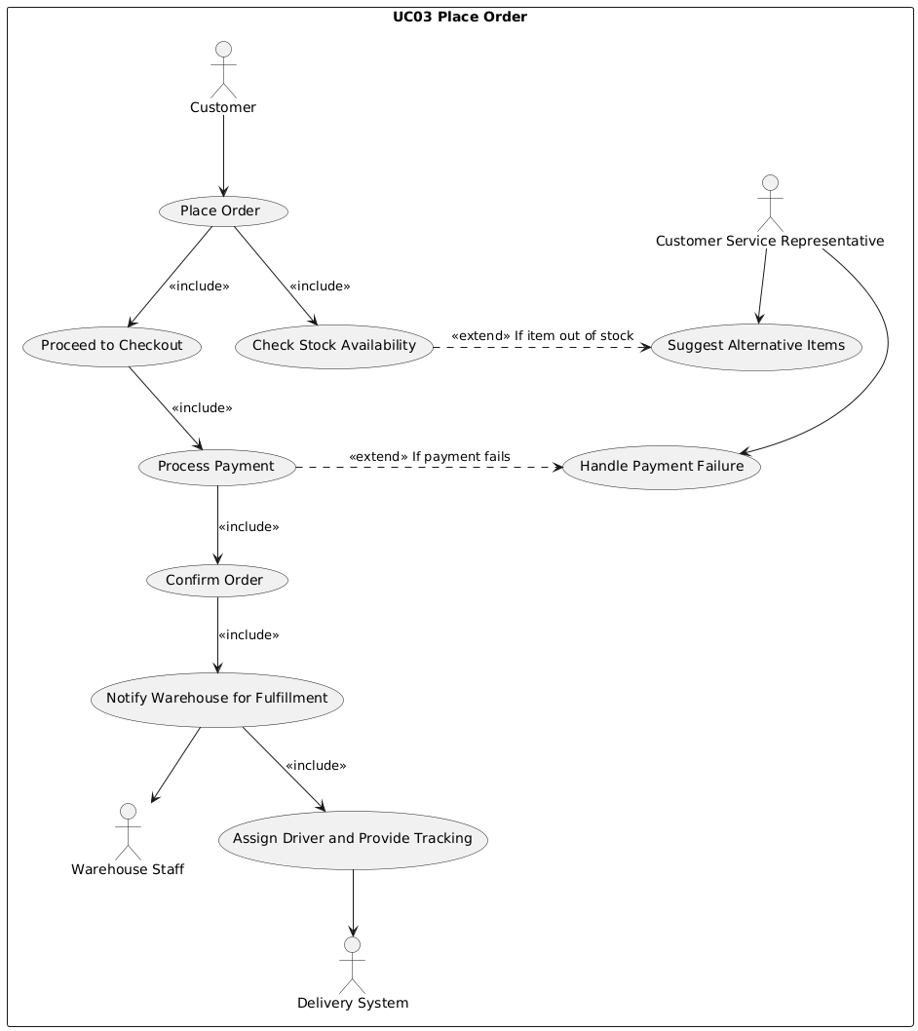

UC04 - Update Delivery Status

| ***Use Case Name*** | Update Delivery Status (UC04) |
| --- | --- |
| ***Goal*** | Update and notify customers about the current delivery status of their orders. |
| ***Actors*** | * Primary: Delivery Driver (triggers update) * Secondary: Customer (receives status updates) |
| ***Stakeholders*** | * Customer - Receives real-time delivery updates. |
| ***Pre-Conditions*** | * A delivery must be scheduled and in progress. * The system must be integrated with the delivery tracking service. |
| ***Post-Conditions*** | * The customer’s order status is updated (ex. In Transit, Delivered) |
| ***Triggers*** | A delivery even occurs (ex. package scanned, shipped, out for delivery, delivered). |
| ***Main Success Scenario*** | 1. The delivery driver updates the order status in the system. 2. The system records the new delivery status. 3. The system notifies the customer about the status change. |
| ***Alternative Paths*** | (2) System unable to fetch delivery updates: The system retries at a later time and/or sends an error notification  (3) Customer notification failure: The system logs the error and resends the notification later. |

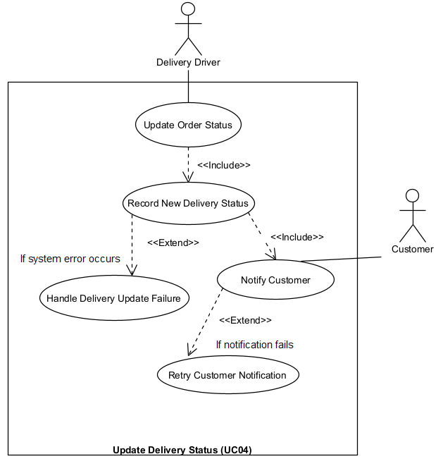

UC05 - Track Order

| ***Use Case Name*** | Track Order (UC05) |
| --- | --- |
| ***Goal*** | Allow customers to track their real-time order status. |
| ***Actors*** | * Primary: Customer |
| ***Stakeholders*** | * Customer - Views real-time updates about their order |
| ***Pre-Conditions*** | * The customer must have an active order in the system. * The system must have up-to-date tracking information from the delivery service. |
| ***Post-Conditions*** | * The customer receives real-time tracking details of their order. |
| ***Triggers*** | The customer initiates a tracking request through the website or app. |
| ***Main Success Scenario*** | 1. The customer logs in and navigates to the tracking section. 2. The customer enters their order number or selects an active order. 3. The system retrieves the latest tracking data from the delivery provider. 4. The system displays real-time status, estimated delivery time, and location updates. |
| ***Alternative Paths*** | (3) Order not found: The system prompts re-entry of the order number, if still not found then suggests contacting support.  (4) System delay in retrieving tracking info: The system notifies the customer of a temporary issue and suggests checking back later. |

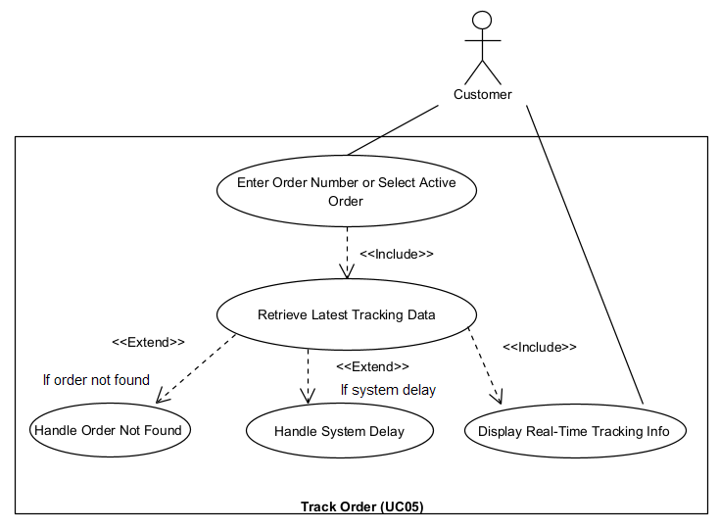

UC06 - Assign Order to Driver

| ***Use Case Name*** | Assign Order to Driver (UC06) |
| --- | --- |
| ***Goal*** | Assign a driver to a new delivery order and notify them. |
| ***Actors*** | * Primary: Warehouse Staff (Manages delivery assignments) * Secondary: Driver (Receives assignment) |
| ***Stakeholders*** | Driver - Receives new delivery assignments.  Warehouse Staff - Ensures the order is ready for pickup. |
| ***Pre-Conditions*** | * A customer order is ready for delivery. * A driver must be available to receive assignments. |
| ***Post-Conditions*** | * The driver is assigned to the order and notified. * The warehouse staff is informed of the assigned driver. |
| ***Triggers*** | A new order is ready for delivery, requiring driver assignment. |
| ***Main Success Scenario*** | 1. The warehouse staff assigns an available driver to a new delivery order. 2. The system records the driver assignment. 3. The system notifies the driver with delivery details. 4. The system updates the warehouse staff with the assigned driver information. |
| ***Alternative Paths*** | (2) No drivers available: The system queues the order and retries later.  (3) Driver notification failed: The system retries notification or escalates the issue to a dispatcher. |

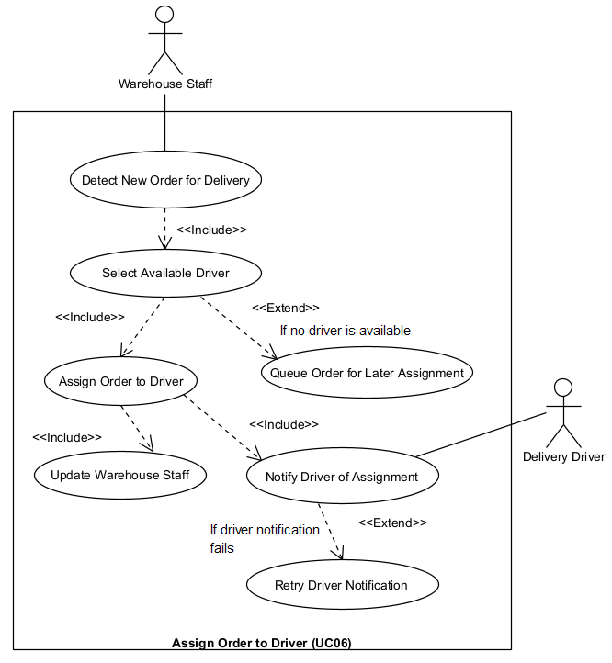

UC07 - Complete Delivery

| ***Use Case Name*** | Complete Delivery (UC07) |
| --- | --- |
| ***Goal*** | Allow the driver to confirm order delivery, notifying the customer. |
| ***Actors*** | * Primary: Driver * Secondary: Customer |
| ***Stakeholders*** | * Customer - Receives confirmation of their delivered order. * Driver - Confirms successful delivery. |
| ***Pre-Conditions*** | * The order must be out for delivery. * The driver must have access to update the delivery status. |
| ***Post-Conditions*** | * The system marks the order as delivered. * The customer receives a delivery confirmation. |
| ***Triggers*** | The driver completes the delivery and marks the order as delivered |
| ***Main Success Scenario*** | 1. The driver arrives at the delivery location. 2. The driver completes the delivery and marks it in the system. 3. The system updates the order status to Delivered. 4. The system notifies the customer that the order has been delivered. |
| ***Alternative Paths*** | (2) Customer not available to receive order: The system prompts the driver to follow the next company protocol (ex. leave package in a safe place, deliver to drop-off location, retry later)  (3) Customer notification failed: System logs the issue and retries sending the notification. |

